4-Week MS-AI/DS/CS/BA Project Guidelines

- Project Structure Overview
  - Total Marks: 20
  - Deadline: 16th of January, 2026
  - Failure to project key takeaways and compliances can affect final exam
  - Students who secure 80% and above will get marks reflection in their previous exams as well where percentages are below 80%
  - A well-organized 4-week AI project typically follows this timeline:
    - Week 1: Foundation & Planning
Define your problem statement clearly, gather and explore your dataset, and set up your development environment. Document your baseline approach and success metrics. This week should end with a working data pipeline.
    - Week 2: Model Development
Implement your initial model, run baseline experiments, and begin iterating. Focus on getting something working end-to-end before optimizing.
    - Week 3: Refinement & Experimentation
Improve model performance through hyperparameter tuning, feature engineering, or architecture changes. Compare multiple approaches and document what works and what doesn't.
    - Week 4: Polish & Presentation
Finalize your best model, create visualizations, write documentation, and prepare your presentation or demo. Ensure reproducibility.

- Key Takeaways with 20 Marks Distribution:
  - Project Documentation [Introduction, Objectives, Technology Benefits, Business Benefits, Project Timeline(Number of hours against tasks), Tech Stack] less than 5 pages (2)
  - Project Working Demo (5)
  - Project Github -- at least 20 commits (2)
  - Project Presentation [Introduction, Objectives, How its related to SDGs, Methodology, Demo Video, QnAs] (3)
  - Short Project Report [includes Literature Review of at least 10 research articles not older than 2024] (5)
  - Student's Attitude, Mindfulness & Awareness towards Project (3)

- How to Update Progress
  - Weekly Check-ins Should Include:
    - What was accomplished vs. what was planned
    - Current blockers or challenges
    - Key metrics and results (with visualizations)
    - Updated timeline if needed
    - Questions or areas where you need guidance

- Documentation Best Practices:
  - Maintain a project journal or log with dated entries
  - Track all experiments in a structured way (use tools like MLflow, Weights & Biases, or even a simple spreadsheet)
  - Version control your code with meaningful commit messages
  - Keep a "lessons-learned" section in the report and branch on github

- What to Avoid
  - Technical Pitfalls
    - Starting with overly complex models before establishing a baseline
    - Data leakage between training and test sets
    - Ignoring data quality issues and diving straight into modeling
    - Not setting aside a proper test set from the beginning
    - Overfitting to your validation set through excessive tuning
  - Project Management Issues
    - Scope creep—trying to add too many features mid-project
    - Spending too much time on data collection and leaving no time for modeling
    - Perfectionism—waiting too long to get something working
    - Poor documentation that makes your work hard to reproduce
    - Not having a backup plan if your main approach fails
  - Presentation Mistakes
    - Claiming results without proper validation
    - Ignoring ethical implications or biases in your data/model
    - Not explaining your work clearly to non-technical audiences
    - Overselling what your model can actually do

- What Makes a Project Exceptional
  - Technical Excellence
    - Clear problem formulation with well-defined success metrics
    - Rigorous experimental methodology with proper train/validation/test splits
    - Thoughtful comparison of multiple approaches with analysis of why one works better
    - Attention to edge cases and failure modes
    - Clean, well-documented, reproducible code
  - Creativity & Impact
    - A novel angle on an existing problem or an underexplored domain
    - Real-world applicability and clear use case
    - Consideration of ethical implications and potential biases
    - A working demo or deployment that people can interact with
  - Communication
    - Clear storytelling that explains the "why" behind your choices
    - Honest discussion of limitations and future improvements
    - Strong visualizations that convey insights effectively
    - Ability to explain technical details to different audiences
  - Going the Extra Mile
    - Deploying your model (even a simple web app or API)
    - Conducting user testing or getting feedback from domain experts
    - Analyzing failure cases and explaining when your model struggles
    - Contributing something back (open-source code, dataset, tutorial)

- MUST ADDRESS ONE OF THE FOLLOWING SDGs:
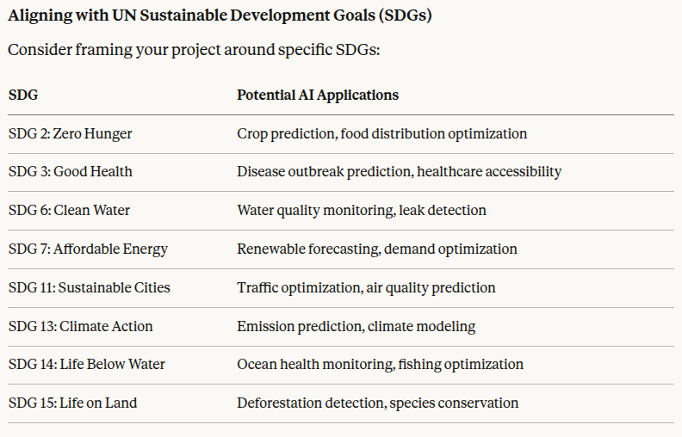

- Suggested Domains & Project Ideas (but you can come up with your own as well that maintains section 7):
  - Healthcare & Medical
    - Disease prediction from patient records or medical images
    - Drug interaction prediction
    - Mental health sentiment analysis from text
  - Natural Language Processing
    - Sentiment analysis for product reviews or social media
    - Text summarization or question-answering systems
    - Chatbot for a specific domain (customer service, education)
  - Computer Vision
    - Object detection for a specific use case (traffic, retail, agriculture)
    - Image classification (plant diseases, product defects)
    - Face mask or safety gear detection
  - Finance & Business
    - Stock price prediction or trend analysis
    - Customer churn prediction
    - Fraud detection system
  - Environment & Sustainability
    - Air quality prediction
    - Wildlife species identification
    - Energy consumption forecasting
  - Education
    - Student performance prediction
    - Automated essay scoring
    - Personalized learning recommendation system
  - Social Good
    - Accessibility tools (sign language recognition, image captioning for visually impaired)
    - Fake news detection
    - Disaster response optimization

